**CPS2231 Computer programming in Java**

* AS1 U1 – 4 : 200pts (10%) : **Each** question is **20pts.**

***Instruction:*** Organisation and w*ell documented program codes and UML diagram will attract marks.*

~~1) a. Describe a class and object.~~

~~b. What is the relationship between them?~~

Using your programming tool such as **EclipsE** **IDE**, COMPLETE the following program exercise with PROGRAM **OUTPUT.**

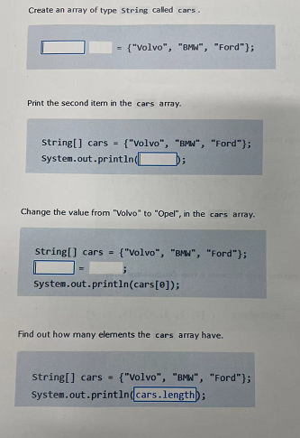

2)

5)

4)

3)

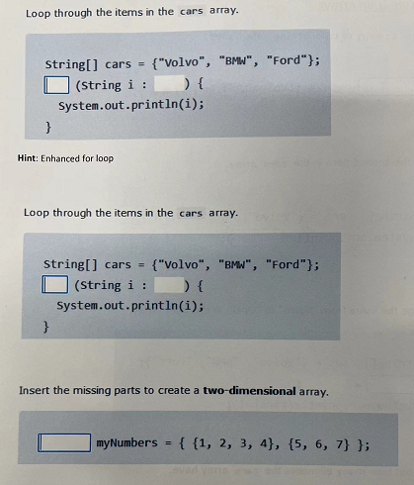

8)

7)

6)

9) With the use of a **UML** tool, construct the TV class diagram and specify the properties as private data.

